#U2 - Nephi
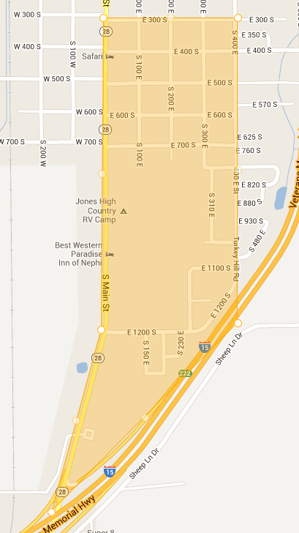

Spanish Addresses

Do Not Calls

Please return to the Delta English
Congregation (435)864-7999

